

**Git and GitHub Project:**

**Branching Development Model**

**Steps to perform:**

1. **Start with the Production branch (master branch), and then create a HotFix  and Integration branch**
2. Cd mkdir Simplilearn_Project
3. Git init
4. Echo Welcome to Git and GitHub Project > git.txt
5. Git status
6. Git add .
7. Git commit –m “ file create”
8. Git status
9. Git branch –m Production
10. Git branch
11. Git branch HotFix
12. Git branch Integraton
13. Git branch

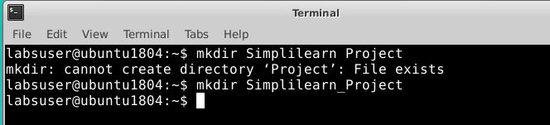

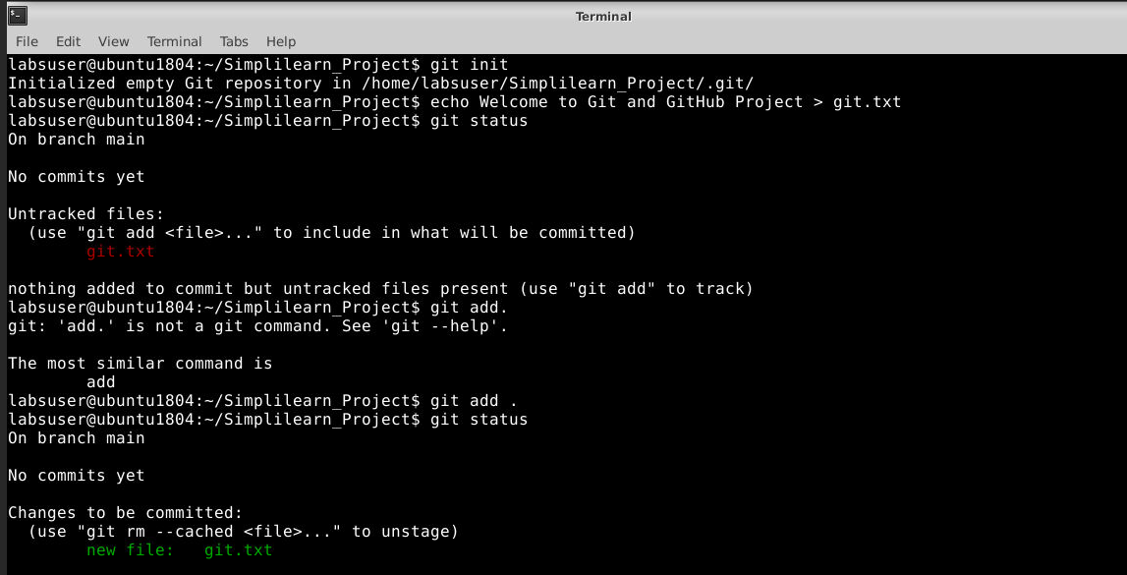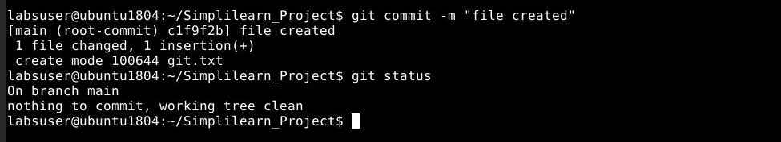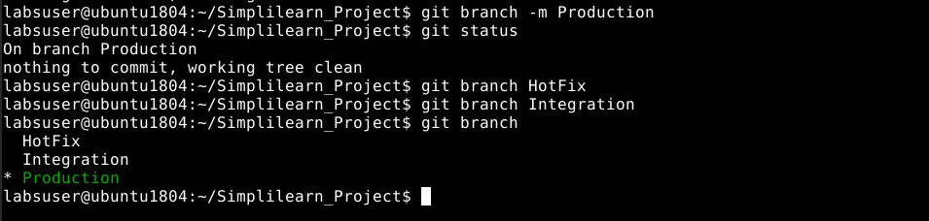

1. **Subsequently, create Feature 1 and 2 branches that integrate to the Integration branch as shown in the above figure**
2. Git checkout Integration
3. Git branch Feature1
4. Git branch Feature2
5. Git status
6. Git branch

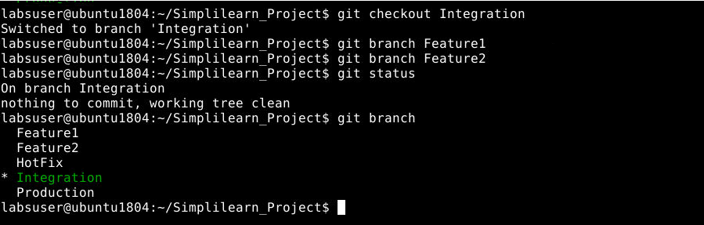

1. **Commit some changes in the Feature 2 branch and merge it into the Integration branch. Delete this branch once merging is complete**

1. Git checkout Feature2
2. Git status
3. Git commit –am “ File modified and commit from Feature2 branch”
4. Git status
5. Git checkout Integration
6. Git merge Feature2
7. Git branch Feature2 -d

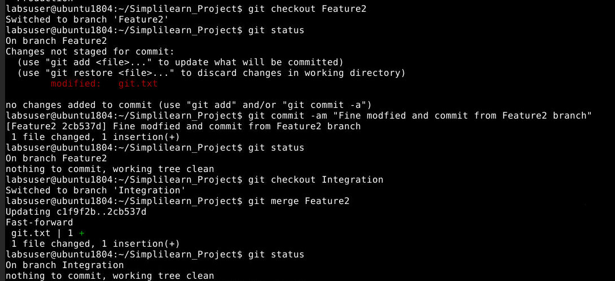

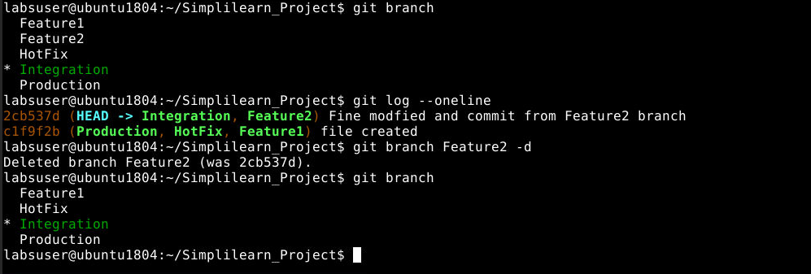

1. **Commit some changes in the Feature 1 branch and rebase it to the Integration branch**
2. Git checkout Feature1
3. Git status
4. Git commit –am “ File modified form Feature1 branch”
5. Git status
6. Git log –oneline
7. Git rebase Integration
8. Resolve the conflict error
9. Git rebase –continue
10. Rebase is done successfully.

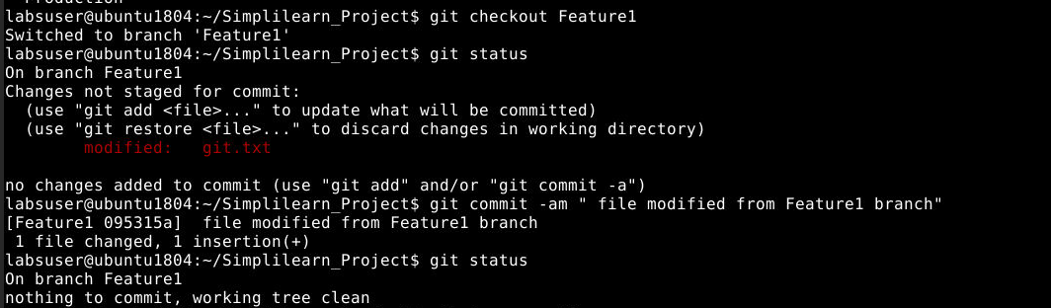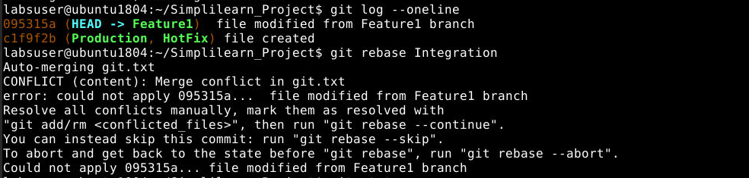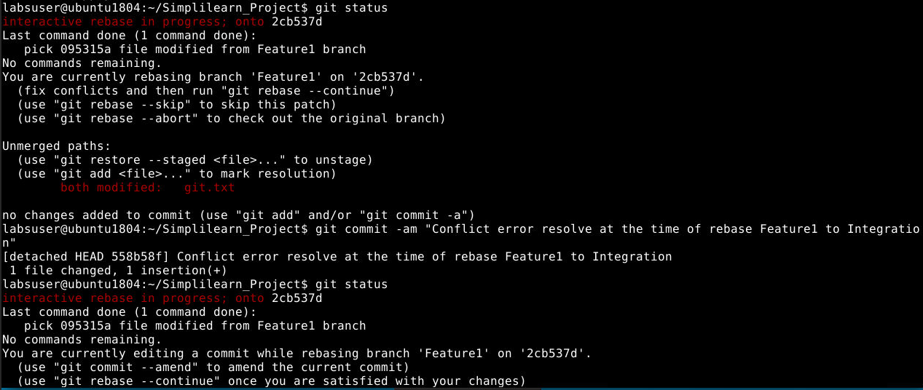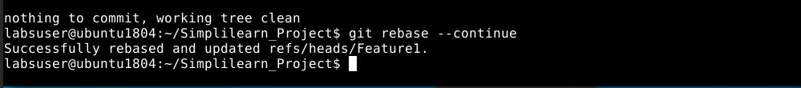

1. **Merge the Integration branch into Hotfix and Production branch to update these branches**
2. Git checkout HotFix
3. Git merge Integration
4. Git checkout Production
5. Git merge Integration
6. Git status
7. Git branch

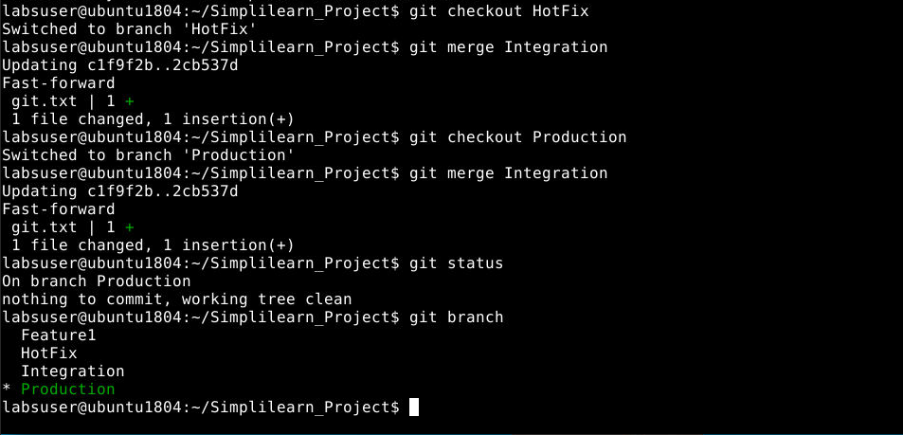

1. **Commit some changes in Feature 1 branch, and then merge it into Integration, Hotfix, and Production branch. Delete this branch once merging is complete**
2. Git checkout Feature1
3. Git status
4. Git commit –am “file modified from Feature1 branch”
5. Git checkout Integration
6. Git merge Feature1
7. Git checkout HotFix
8. Git merge Feature1
9. Git checkout Production
10. Git merge Feature1
11. Git status
12. Git branch
13. Git branch Feature1 -d

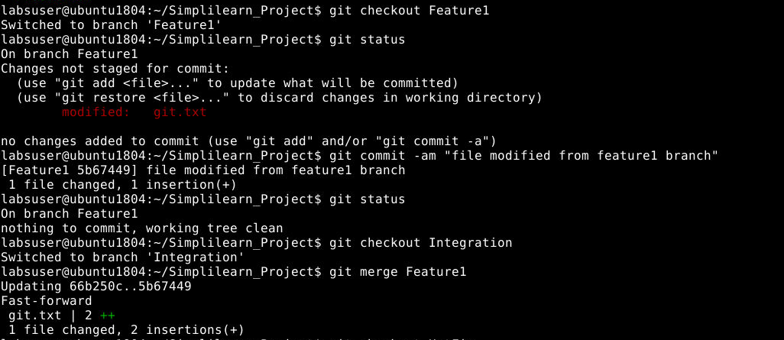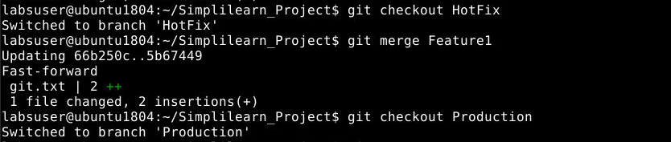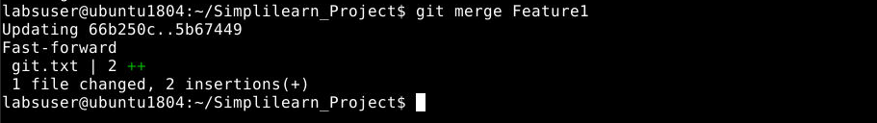

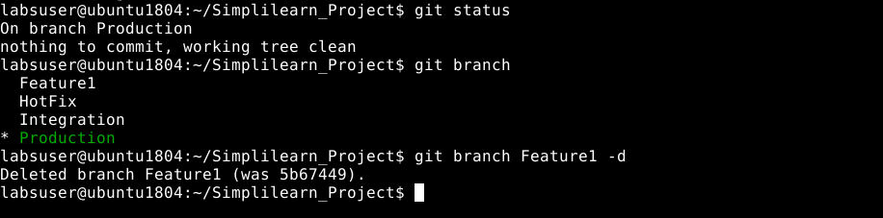

1. **Commit some changes in the Hotfix branch and merge it into the Production as well as the Integration branch**
2. Git checkout HotFix
3. Git status
4. Git commit –am “ file committed in HotFix branch”
5. Git status
6. Git checkout Production
7. Git status
8. Git merge HotFix
9. Git checkout Integration
10. Got status
11. Git merge HotFix
12. Git status
13. Git branch

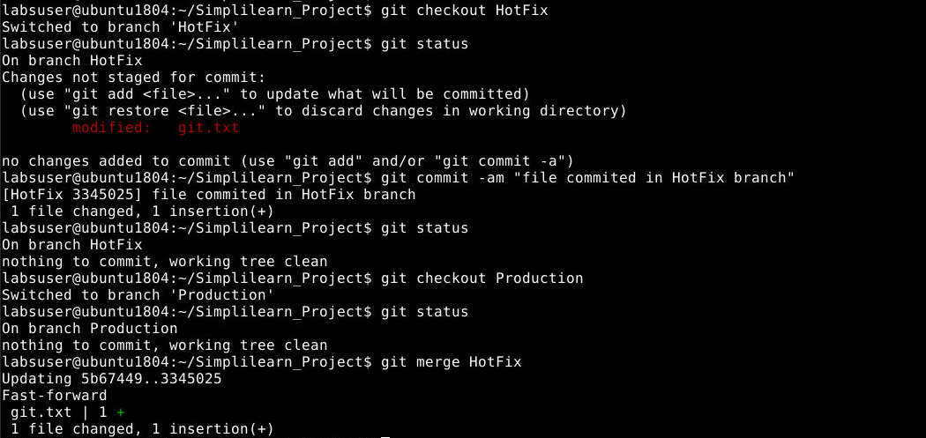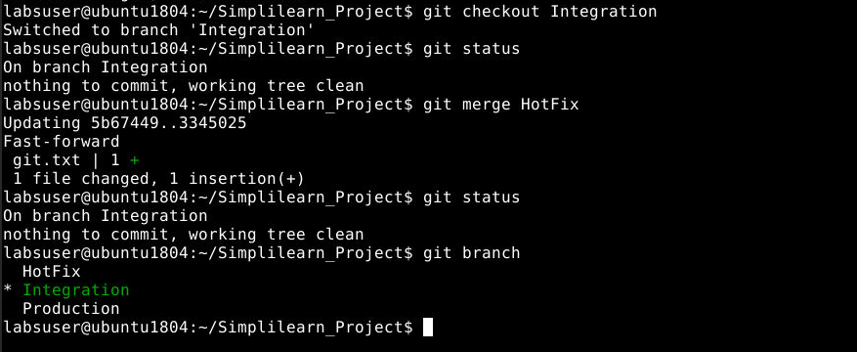

**View Log:**

1. **Git log –oneline**

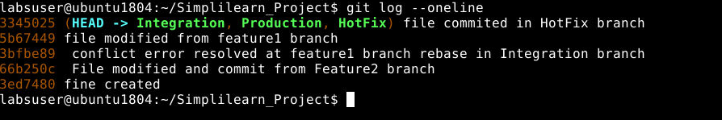

1. **Git reflog**

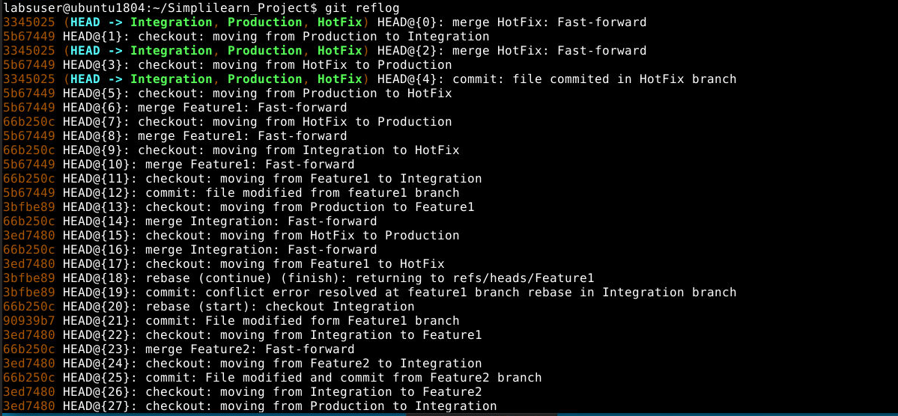

The Project End.

Thank you. !!!